**Part 1: Problem Definition**

**1. SDG Selection:**

* **SDG 1: No Poverty**

**2. Problem Definition:**

* **Problem:** Many individuals struggle with financial management, leading to overspending, inadequate savings, and increased financial stress. The goal is to help users track expenses, manage budgets, and gain insights into their spending habits to promote financial stability.

**Part 2: Database Design**

**1. ERD (Entity-Relationship Diagram):**

* **Entities:**
  + **Users**: Information about the app users.
  + **Expenses**: Records of expenses incurred by users.
  + **Categories**: Various categories under which expenses are recorded.
  + **Income**: Records of income entries.
  + **Financial_Goals**: User-defined financial goals.
* **Relationships:**
  + **Users** to **Expenses** (One-to-Many)
  + **Users** to **Income** (One-to-Many)
  + **Users** to **Financial_Goals** (One-to-Many)
  + **Categories** to **Expenses** (One-to-Many)
* **ERD**
* 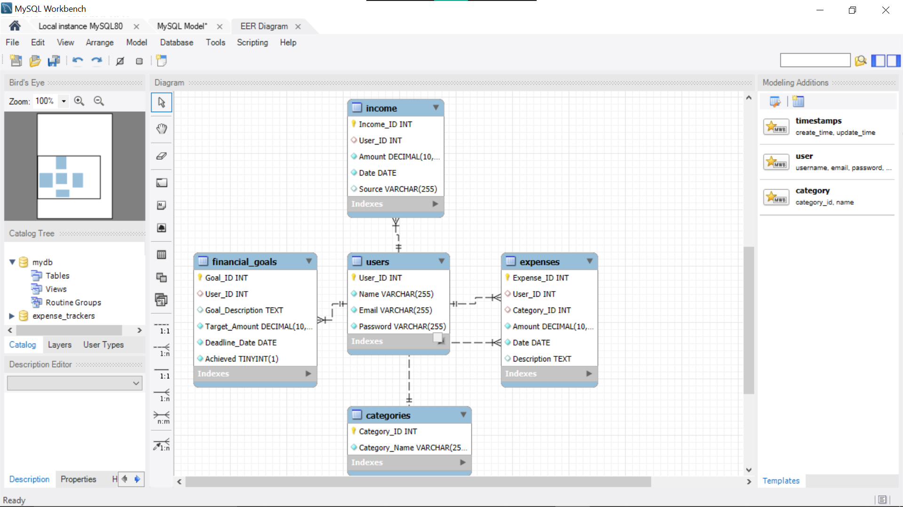

**expense_trackers**

**2. Schema:**

CREATE DATABASE IF NOT EXISTS expense_trackers;

USE expense_trackers;

CREATE TABLE Users (

User_ID INT AUTO_INCREMENT PRIMARY KEY,

Name VARCHAR(255) NOT NULL,

Email VARCHAR(255) NOT NULL UNIQUE,

Password VARCHAR(255) NOT NULL

);

CREATE TABLE Categories (

Category_ID INT AUTO_INCREMENT PRIMARY KEY,

Category_Name VARCHAR(255) NOT NULL

);

CREATE TABLE Expenses (

Expense_ID INT AUTO_INCREMENT PRIMARY KEY,

User_ID INT,

Category_ID INT,

Amount DECIMAL(10, 2) NOT NULL,

Date DATE NOT NULL,

Description TEXT,

FOREIGN KEY (User_ID) REFERENCES Users(User_ID),

FOREIGN KEY (Category_ID) REFERENCES Categories(Category_ID)

);

CREATE TABLE Income (

Income_ID INT AUTO_INCREMENT PRIMARY KEY,

User_ID INT,

Amount DECIMAL(10, 2) NOT NULL,

Date DATE NOT NULL,

Source VARCHAR(255),

FOREIGN KEY (User_ID) REFERENCES Users(User_ID)

);

CREATE TABLE Financial_Goals (

Goal_ID INT AUTO_INCREMENT PRIMARY KEY,

User_ID INT,

Goal_Description TEXT,

Target_Amount DECIMAL(10, 2) NOT NULL,

Deadline_Date DATE NOT NULL,

Achieved BOOLEAN NOT NULL,

FOREIGN KEY (User_ID) REFERENCES Users(User_ID)

);

**3. Sample Data:**

### -- Insert sample users

### INSERT INTO Users (Name, Email, Password)

### VALUES

### ('John Doe', 'john@example.com', 'password123'),

### ('Jane Smith', 'jane@example.com', 'password456');

### -- Insert sample categories

### INSERT INTO Categories (Category_Name)

### VALUES

### ('Groceries'),

### ('Rent'),

### ('Utilities'),

### ('Entertainment');

### -- Insert sample expenses

### INSERT INTO Expenses (User_ID, Category_ID, Amount, Date, Description)

### VALUES

### (1, 1, 100.50, '2024-08-01', 'Weekly grocery shopping'),

### (1, 2, 1200.00, '2024-08-05', 'Monthly rent payment'),

### (2, 3, 60.00, '2024-08-03', 'Electricity bill'),

### (2, 4, 45.00, '2024-08-07', 'Movie tickets');

### -- Insert sample income

### INSERT INTO Income (User_ID, Amount, Date, Source)

### VALUES

### (1, 3000.00, '2024-08-01', 'Salary'),

### (2, 2500.00, '2024-08-01', 'Freelance work');

### -- Insert sample financial goals

### INSERT INTO Financial_Goals (User_ID, Goal_Description, Target_Amount, Deadline_Date, Achieved)

### VALUES

### (1, 'Save for vacation', 2000.00, '2024-12-31', FALSE),

### (2, 'Emergency fund', 5000.00, '2024-12-31', FALSE);

### ****Part 3: SQL Programming****

**1. Retrieve Total Expenses by Category for a User:**

SELECT c.Category_Name, SUM(e.Amount) AS Total_Amount

FROM Expenses e

JOIN Categories c ON e.Category_ID = c.Category_ID

WHERE e.User_ID = 1

GROUP BY c.Category_Name;

**2. Calculate Total Income for a User**

SELECT SUM(Amount) AS Total_Income

FROM Income

WHERE User_ID = 1;

**3. List All Financial Goals and Their Status:**

SELECT Goal_Description, Target_Amount, Deadline_Date, Achieved

FROM Financial_Goals

WHERE User_ID = 1;

**Part 4: Data Analysis Using Excel**

**1. Import Data:**

* Export data from MySQL to CSV files and then import them into Excel.

**2. Analysis:**

* **Pivot Tables:** Create pivot tables to summarize total food distribution by neighborhood and category.
* **Charts:** Generate bar charts or pie charts to visualize food distribution trends.

**3. Dashboard:**

* **Interactive Dashboard:** Use Excel features to create an interactive dashboard showing key metrics like total distribution, category-wise distribution, and neighborhood comparisons.

**Part 5: Integration and Testing**

**1. Integration:**

* Document the steps to import data into Excel and ensure all data is consistent and correctly mapped.

**2. Testing:**

* Verify the accuracy of the dashboard by cross-referencing with SQL query results. Test interactive elements to ensure they work as intended.

**Part 6: Presentation**

**1. Pitch Deck:**

* **Slide 1:** Title Slide
* **Slide 2:** Overview of SDG 2 and its importance
* **Slide 3:** Problem definition and significance
* **Slide 4:** ERD and database schema
* **Slide 5:** SQL queries and data retrieval
* **Slide 6:** Data analysis results
* **Slide 7:** Excel dashboard demonstration
* **Slide 8:** Integration process
* **Slide 9:** Testing and validation
* **Slide 10:** Conclusion and next steps

**Slide 1: Title Slide**

**Title:** Expense Tracker App  
**Subtitle:** Empowering Individuals to Achieve Financial Stability  
**Your Name:** Bramwel Vasaka  
**Date:** 10th August, 2024

**Slide 2: Problem Statement and SDG Alignment**

**Title:** The Financial Management Challenge  
**Content:**

* **Problem:** Many individuals face challenges in tracking expenses, managing budgets, and saving money effectively.
* **Impact:** Poor financial management can lead to overspending, debt, and financial stress.
* **SDG Alignment:** Supports **SDG 1: No Poverty** by helping users achieve better financial control and avoid poverty traps.

**Slide 3: Importance of Financial Management and Target Audience**

**Title:** Why Financial Management Matters  
**Content:**

* **Importance:** Financial stability is crucial for reducing poverty and improving quality of life.
* **Target Audience:** Individuals aged 18-45, particularly those seeking to improve their financial habits and achieve savings goals.

**Slide 4: ERD and Database Schema**

**Title:** Database Design Overview  
**Content:**

* **ERD (Entity-Relationship Diagram):** Illustrates the relationships between users, expenses, income, categories, and financial goals.
* **Schema:** Logical structure of the database, defining how data is organized and connected.

**Visuals:**

* **ERD Diagram:** Visual representation of the entities and their relationships.
* **Database Schema:** Summary of tables and key fields.

**Slide 5: SQL Queries for Data Retrieval and Analysis**

**Title:** SQL for Data Insights  
**Content:**

* **Data Retrieval:** Queries to fetch user-specific expenses, income, and financial goals.
* **Data Analysis:** Queries to analyze spending patterns, compare income vs. expenses, and monitor progress toward financial goals.

**Visuals:**

* **Example SQL Queries:** Code snippets demonstrating key SQL queries.

**Slide 6: Data Insights**

**Title:** Uncovering Spending Patterns  
**Content:**

* **Key Insights:**
  + **Spending by Category:** Breakdown of expenses across different categories.
  + **Monthly Trends:** Analysis of how spending changes over time.
  + **Income vs. Expenses:** Visualization of income in relation to expenses, highlighting potential savings or overspending.

**Visuals:**

* **Charts and Graphs:** Bar charts, pie charts, or line graphs showing spending patterns and comparisons.

**Slide 7: Excel Dashboard Demonstration**

**Title:** Interactive Dashboard  
**Content:**

* **Dashboard Features:**
  + **Total Expenses by Category**
  + **Monthly Spending Trends**
  + **Income vs. Expenses**
  + **Progress Toward Financial Goals**
* **User Experience:** Intuitive interface allowing users to filter data, view detailed reports, and track their financial health.

**Slide 8: Integration Process and Data Flow**

**Title:** From Database to Dashboard  
**Content:**

* **Integration Process:**
  + **Data Export:** Exporting data from MySQL to CSV.
  + **Data Import:** Importing CSV files into Excel.
  + **Data Consistency:** Ensuring accurate data mapping and consistency across platforms.
* **Data Flow:** End-to-end process from data entry in the app to visual representation in the Excel dashboard.

**Visuals:**

* **Flow Diagram:** Visual representation of the integration process from MySQL to Excel.

**Slide 9: Testing and Validation**

**Title:** Ensuring Accuracy and Reliability  
**Content:**

* **Testing:** Cross-reference SQL results with Excel data to validate accuracy.
* **Validation:** Test interactive elements to ensure correct functionality.
* **Outcome:** Reliable and user-friendly tool for managing personal finances.

**Visuals:**

* **Testing Reports or Screenshots:** Examples showing the testing process and outcomes.

**Slide 10: Conclusion and Future Enhancements**

**Title:** Next Steps and Vision  
**Content:**

* **Conclusion:** The Expense Tracker app provides a robust solution for personal financial management, helping users achieve their financial goals.
* **Future Enhancements:**
  + **Mobile Integration:** Develop a mobile app for on-the-go expense tracking.
  + **AI-Powered Insights:** Implement AI to provide personalized financial advice.
  + **Advanced Reporting:** Add more detailed financial reports and forecasting tools.

**Call to Action:**

* **Get Started:** Encourage the audience to try the app and take control of their finances today.

**Visuals:**

* **Vision for the Future:** Imagery or graphics representing the future of the app.

